Wellington Hockey Association

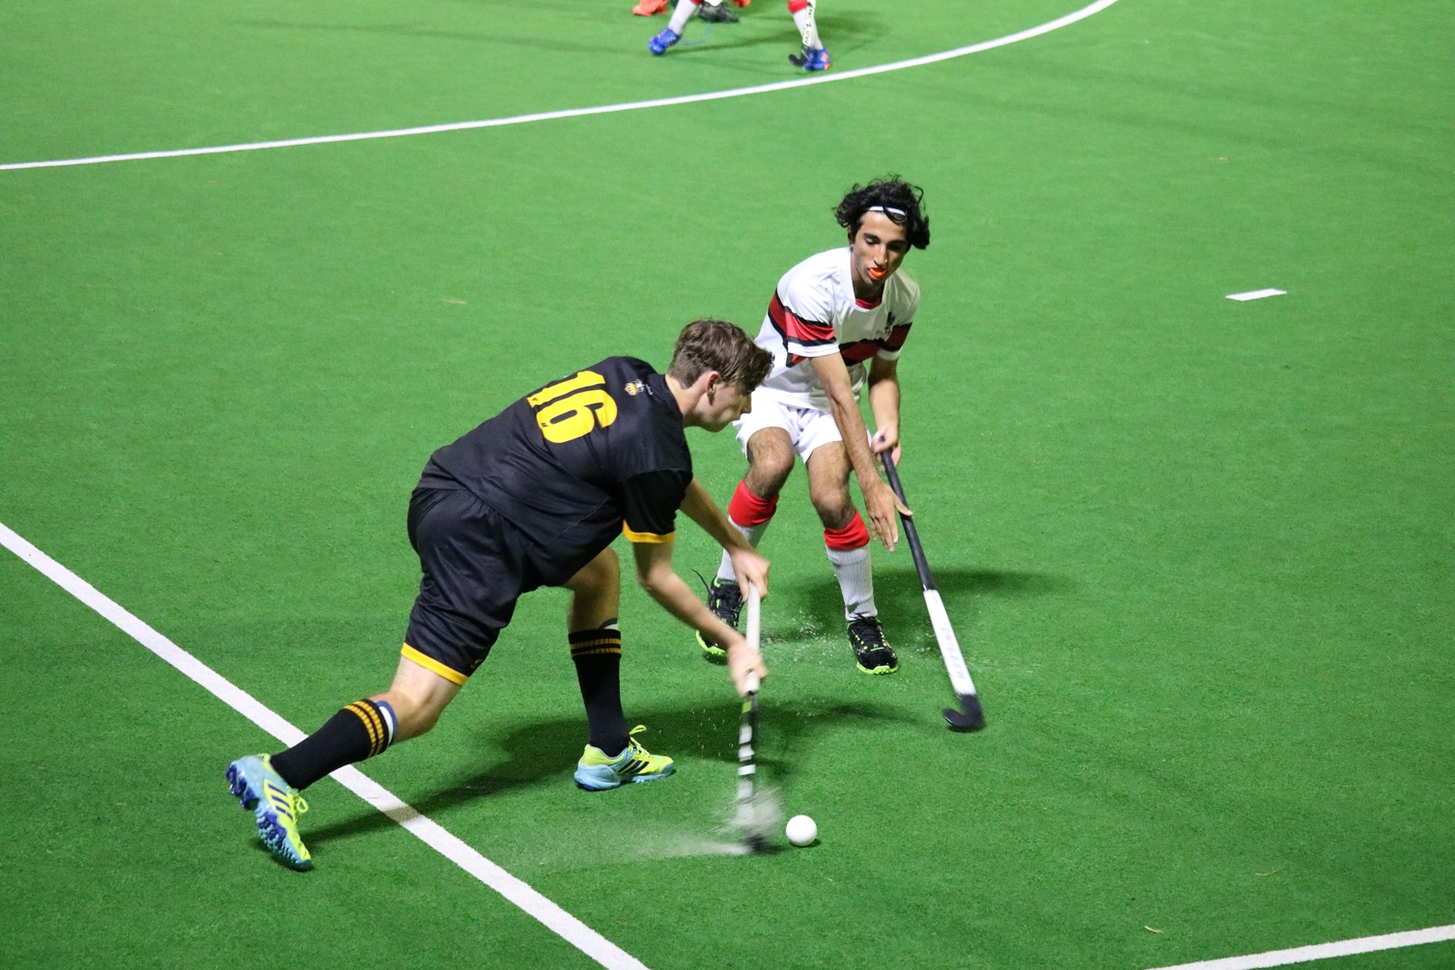

2024 Secondary School Competition Handbook

CONTENTS
2024 Season Information
1.1 Key Dates
1.2 Competition Fees
1.3 Game Days

Team Registrations
2.1 Where to Register
2.2 Number of Teams
2.3 Standings and Seedings
2.4 Challenge System
2.5 New Team
2.6 Number of Players Per Team
2.7 Uniform Registration

Player Registrations
3.1 Where to Register
3.2 New Players
3.3 Grading of Players

On Match Day
4.1 Umpires
4.2 Number of Players
4.3 Match Cards
4.4 Duration of Games
4.5 Game Result
4.6 Equipment
4.7 Uniforms
4.8 Blood Bins

Defaults, Cancellations and Abandoned Games
5.1 Defaults
5.2 Cancellations
5.3 Abandoned Matches
5.4 Deferrals

Premier Competition Structure
6.1 Grade Specific Rules
6.2 Term 2 – P1, P2 and P3
6.3 Term 3 – Divisional Round
6.4 Determining a Winner
6.5 Promotion and Relegation
6.6 Competition Format

Reserve Grade
7.1 Format

Y9-10s Grade
8.1 Format
8.2 Grade Specific Rules

7-A-Side Competition Structure
9.1 7-a-side Format

Extra Time Procedures
10.1 Shoot outs – P1 to P3
10.2 Shoot outs between two teams
10.3 Shoot outs between two or more teams
10.4 Strokes

Competition Finer Details
11.1 Competition Round Ladders
11.2 Competition Points
11.3 Final Round
11.4 Card System

Judicial Committee
12.1 Judicial system

1. 2024 SEASON INFORMATION
1.1 KEY DATES
Team Registrations Close | 5th April 2024
Player Registration Closes | 3rd May 2024
Finals Dates | Term 2: 28th June 2024  Term 3: 23rd August 2024
1.2 COMPETITION FEES
1.2.1 The 2024 Affiliation Fee for each 11-a-side team is $586.00 and for each 7-a-side team is $197.00. These fees must be paid no later than 7th June 2024.
1.2.2 The fee includes a HNZ player affiliation fee, and partially funds the administration of the competition.
1.2.3 The rate for a turf is $53.00 per game per team for P1, P2 & P3 teams, and $42.00 per game per team for teams in all other 11-a-side grades. The rate for 7-a-side games per team is $33.00.
1.2.4 The turf invoices will be sent at the beginning of the season and can be paid monthly divided up over the season. We will do a wash up at the end of the season and invoice or reimburse as required.
1.2.5 COVID contingency, should the competition be interrupted by a government lockdown or sanction, WHA will endeavour to complete the season by extending its length or providing an alternative competition/festival that would consider the games missed. Where this is not possible, and the season is affected by a loss of games equating to 30% or more of the season WHA will provide a refund of training and game hire costs minus a fee for any fixed costs.
1.3 GAME DAYS
Wednesday | Years 9-10 | 16:00-19:30pm
Thursday | 7-a-side/Reserve Grade | 16:00-18:30pm
Friday | P1, P2 & P3 | 16:20-21:40pm
2. TEAM REGISTRATION
2.1 WHERE TO REGISTER TEAMS
2.1.1 Schools must register their teams no later than 5th of April 2024. The link to the PlayHQ team registration will be emailed to all secondary school contacts. There is a different link for individual player registrations if you require this, please refer 3.1.
2.2 NUMBER OF TEAMS
2.2.1 Schools can register the following maximum number of teams per grade:
P1 | One Team
P2 & P3 | Two Teams
Y9-10, Reserve & 7-a-side | Unlimited

2.2.2 At registration, all Premier and Reserve teams must be ranked from highest to lowest, with 1 being the highest (ie: 1st XI, not P3 Girls).
2.2.3 At registration, all Y9-10 teams must be called “(School or Combination Name) Junior Boys/Girls”.
2.2.4 If there are two or more Y9-10 or 7-a-side teams at one school, schools must not “stream” their teams into 1st XI, 2nd XI etc. Schools must mix the teams for even competition and development purposes.
2.3 STANDINGS AND SEEDINGS
2.3.1 The start of the 2024 season will start how the 2023 season finished.
(a) If teams wish to change grades they will need to go through the challenge process (refer to 2.4).
(b) If a school already has the maximum number of teams in the higher grade, no team will be eligible to challenge or be promoted into that grade.
2.4 CHALLENGE PROCESS
2.4.1 After the final of each grade, the winning team will not require a challenge game versus a team of the grade above, subject to the rules of that grade outlined in section 6, 7 or 8 below.
- If there is already the maximum number of school teams in that grade no challenge will take place (refer to 2.2).
2.4.2 If a team does not wish accept promotion, then the team in the grade above will not be forcibly relegated to the grade below.
2.4.3 WHA holds the ability at their discretion to move teams in-season to up-hold meaningful competition and in the interest of Hockey.
2.5 NEW TEAM
2.5.1 Any new team into the competition must be entered into the lowest grade.
2.5.2 A school may apply for a team to be placed in a better suited grade. This will be decided on a case-by-case basis and will be at the discretion of WHA. Applications must be made before the deadline date of team registrations (5th April 2024).
2.6 NUMBER OF PLAYERS PER TEAM
2.6.1 The minimum number of players to be registered in each 11-a-side teams is twelve.
2.6.2 The minimum number of players to be registered in each 7-a-side team is seven.
2.7 UNIFORM REGISTRATION
2.7.1 Please send a photo of your uniform when you register your team to competitions@wellingtonhockey.org.nz. This is to ensure no clashes occur during the season. If this happens, the second named team on the draw will be required to wear an alternative strip or bibs.

3. PLAYER REGISTRATION
3.1 WHERE TO REGISTER
3.1.1 Schools must register all players by the 3rd May 2024. The registration link for this will be communicated once all teams have accepted the competition invite and WHA can allocate teams to their matching grade.
3.1.2 All players must be registered before taking to the turf.
3.1.3 Individuals who do not have access to a team through their own school are eligible to register using the individual registration link on PlayHQ. WHA will manage these individuals in conjunction with other schools and clubs to create new combined teams or allocate to existing school teams.
3.1.4 For players unsure where to register or play in the 2024 season, please refer to flowchart below

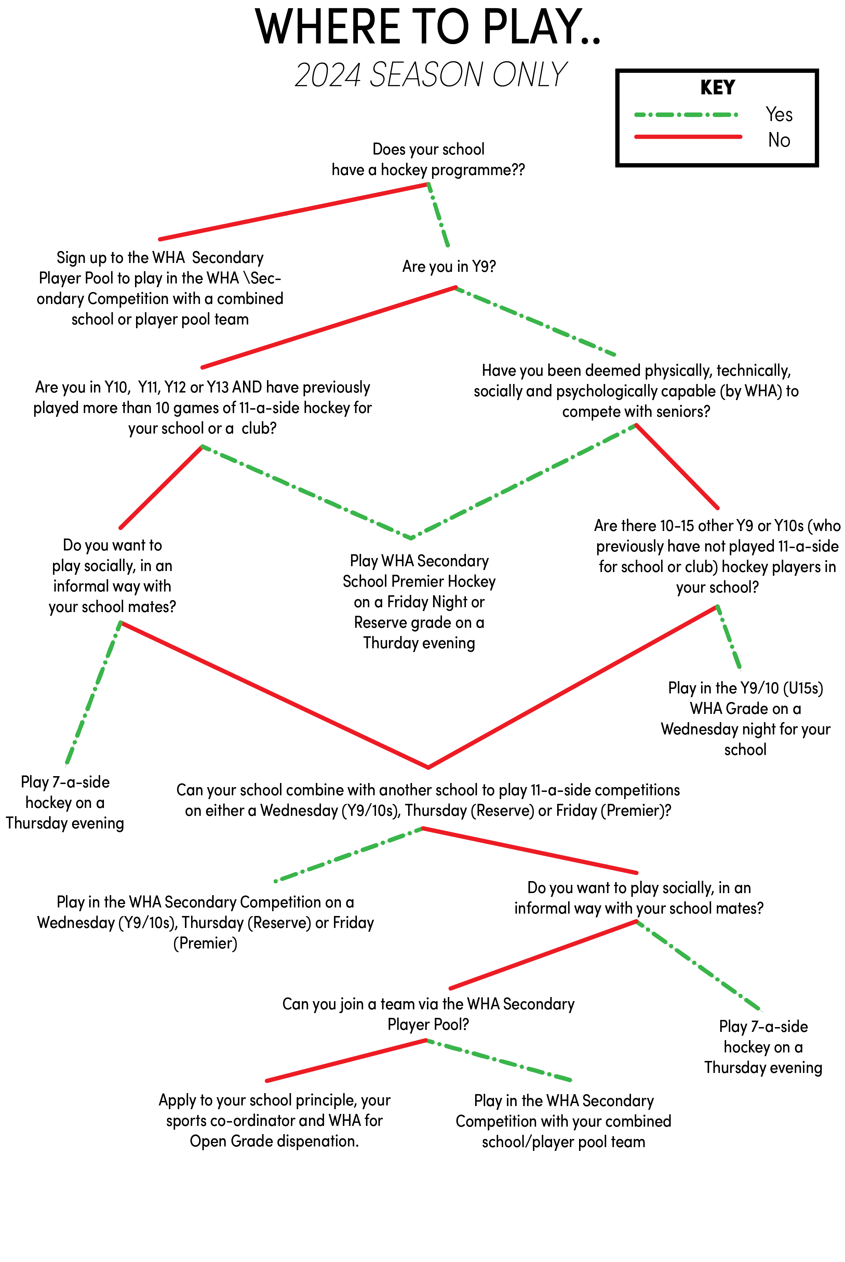
3.2 NEW PLAYERS
3.2.1 New players may be added to a team during the season, but must be registered before they take the field. New players must be registered and have played two games before the end of the competition round (in either Term 2 or Term 3) to be eligible for finals.
3.3 GRADING OF PLAYERS
3.3.1 If a player plays two times in a higher graded team than they are registered, they cannot return to their original lower graded team. They must be re-registered by the school in the higher grade by contacting competitions@wellingtonhockey.org.nz.
3.3.2 A player may only be regraded once in a season, at the discretion of WHA.
3.3.3 A goalkeeper may be registered as a field player for a lower or a higher graded team. An application form for such registration must be completed and submitted to WHA for approval.
3.3.4 Players may be regraded during the Finals rounds. Teams needing players from lower grades may apply to WHA. The intention of this rule is to allow schools to field teams but not regrade a higher-grade player to a lower team. This would need to be done prior to finals and in line with rule 3.3.2.
3.3.5 An application for regrading must be completed and submitted to WHA for approval.
    - Subject to 3.3.7, every player must:

- Be a bona fide pupil of the school; or a member of an approved cluster school or be taking a minimum of four subjects; and

- Be in Year 9-13

    - Dispensation can be requested for up to three players who are not attending the school either to make up numbers or for the development of that player. An application for such registration must be completed and submitted to WHA for consideration and approval on a case-by-case basis.
3.3.8 All teams competing in the WHA Secondary Competition will adhere to the NZSSSC and College Sport Wellington by-laws ‘New to School’ students and ‘Non Domestic’ students.
3.3.9 WHA will adopt the NZSSSC & College Sport Wellington by-laws in relation to the creation of new schools entering teams for the first time in WHA competitions, as all players will be identified as ‘new to school’.
3.3.10 A Starred Player (*) is one who can play in a higher grade in P1, P2, P3 and Reserve only. Please be aware that the 9-10 grade is independent of other Secondary school hockey grades.
3.3.11 Starred players can play in a higher grade than that in which they are registered. Teams may have a maximum of three Starred Players to assist with one of the following;
* To enable the school to field another team (NUMBERS).
* To facilitate the development of younger players (DEVELOPMENT).
Starred Players must be approved by WHA. Requests for players to be starred, along with reasons why they are to be starred must be emailed to WHA, by 10th May 2024. Each Starred Player will be registered in the lower team and play up when required.
3.3.12 Schools can apply for dispensation. This will be considered in the best interest of Hockey. Email competitions@wellingtonhockey.org.nz with any requests.
3.3.13 Schools must register all players through the registration form by the 3rd May 2024.
3.3.14 All players must be registered and added to a game card before taking to the turf. See Appendix 1 for PlayHQ support and pre-match requirements.

4. ON MATCH DAY
4.1 UMPIRES
4.1.1 The umpires are the sole judges of the match rules and duration in conjunction with WHA and the Competitions Officer (it is their interpretation of the handbook).
4.1.2 The umpires shall enforce the Rules of the Game 2024 as issued by the International Rule Board under the authority of the FIH, and this 2024 Secondary School Handbook.
4.1.3 Where possible WHA will provide umpires for P1, P2 and P3 games. Where WHA has not appointed an umpire for a game, each team must provide an umpire.
4.2 NUMBER OF PLAYERS
4.2.1 A team may name a maximum of eighteen players for a game, of whom two must be bona fide goalkeepers wearing full protective equipment. If a team does not include a second goalkeeper, it may only name a maximum of sixteen players for the game, including a goalkeeper.
4.2.2 A 11-a-side game cannot start or continue unless both teams have a minimum of seven players present on the field of play.
4.2.3 A 7-a-side game cannot start or continue unless both teams have a minimum of four players present on the field of play.
4.2.4 A team which does not have the minimum number of players to play or continue a game, must default the game (refer to 5.1.7).

4.3 MATCH CARDS
4.3.1 Match cards can be found on the PlayHQ competition system.
4.3.2 Match cards must contain the names of no more than eighteen players (two bona fide goal keepers) or sixteen players (one bona fide goalkeeper)
4.3.3 Match cards must record First Names, Surnames and, in the case of P1 games, Shirt Numbers.
4.3.4 Teams must complete their line up on PlayHQ before entering the field of play. See Appendix 1 for full details.
4.3.5 Teams must review the match results after the completion of the game and input any incidents into the PlayHQ game record.
4.3.6 Goalkeepers playing “down” as a field player and Starred Players playing “up” must be clearly marked on the Match Card, identified to WHA via email by noon on the day of the fixture and explained to the opposition and umpires before the start of the game.
4.4 DURATION OF GAMES
4.4.1 Grades running times
P1 – P3 GRADES |  | R1 & Y9-10s GRADE |  | 7-A-SIDE
Q1 | 15 minutes | Q1 | 15 minutes | Q1 | 12 minutes
Break | 2 minutes | Break | 2 minutes | Break | 2 minutes
Q2 | 15 minutes | Q2 | 15 minutes | Q2 | 12 minutes
HT | 2 minutes | HT | 2 minutes | HT | 2 minutes
Q3 | 15 minutes | Q3 | 15 minutes | Q3 | 12 minutes
Break | 2 minutes | Break | 2 minutes | Break | 2 minutes
Q4 | 15 minutes | Q4 | 15 minutes | Q4 | 12 minutes

    - Premier Grades will be given 80 (eighty) minutes on the turf, using a running clock system. U15s and 7-a-side will be given 75 (seventy five) minutes on the turf. Due to the collation of Premier grades to one evening, there will be now be four games per turf each Friday. These will start at 16:20, 17:40, 19:00 and 20:20.

    - For all grades, games must start on time and umpires reserve the right to start the game, regardless of number of players on the field, from one minute after the allocated game start time (eg: 16:21 for a 16:20 start). The clock will not be stopped due to the ball leaving the playing surface (see rule 4.6.1).

    - Premier grades will be required to finish no later than 5 (five) minutes before the start of the next game. This still allows for 9-10 minutes of potential delays or umpire clock stoppages.

    - If a fixture will not finish before the start of the next game due to delays from either team, the fourth quarter clock will be reduced accordingly to ensure games will finish 5 minutes before the next fixture is due to start.

    - For all grades, if the game is due to run into the next time slot due to injuries, concussions or umpire prompted clock stoppages, the game will be allowed to continue until the end.

    - Due to council permits, the lights at each turf must be off before 9:45pm. If a game is still being played when the majority of lights turn off, the game stops immediately and the result is taken as if the lights were the final whistle (as per 5.3).
4.5 GAME RESULTS
4.5.1 Results will be recorded on PlayHQ at the end of the fixture by the Team Manager or Coach. The person populating the card will need to check with the Umpires and Officials that the score, the penalty cards and any injuries are correct.
4.5.2 The winning team, or first named team in the case of a draw, will input the result and any incidents, including cards, into PlayHQ.
4.5.3 Any incorrect information must be reported to WHA via competitions@wellingtonhockey.org.nz.
4.6 EQUIPMENT
4.6.1 Each team must supply two white balls for each game. Teams will agree which ball will be used before the game, with the spares being used in case of the match ball leaves the fenced area. A coloured ball may be used as an alternative if playing under lights makes a white ball difficult to see.
4.6.2 No outfield player may take the field unless they are wearing shin pads and a mouth guard.
4.6.3 No player may wear a peaked cap, although collapsible sun visors may be worn.
4.6.4 Each team must carry a first aid kit including water and ice.
4.7 UNIFORMS
4.7.1 Goalkeepers must wear protective equipment and a different coloured shirt from that of both teams.
4.7.2 Track pants may not be worn as a playing uniform.
4.7.3 Each P1 player must wear a shirt with a number on the back at least 30cm in height. Each P1 goalkeeper must have their number on their back.
4.8 BLOOD BINS
4.8.1 If a player is bleeding or has an open wound, they must leave the turf and are not to return until the injury has been treated.
4.8.2 Blood-stained clothes must be replaced.
4.8.3 Blood stains on the turf must be cleaned up immediately.
4.8.4 Alcohol for cleaning up bloodstains is available at:
National Hockey Stadium - Under notice board near match cards.
Fraser Park - In the foyer.
Kapiti - Kiosk first aid box.
Elsdon and Maidstone do not have alcohol available. Please advise WHA that blood is on the turf.

5. DEFAULTS, CANCELLATIONS AND ABANDONED GAMES
5.1 DEFAULTS
5.1.1 If a team wishes to default a scheduled game, WHA must be notified by phone call no later than noon on the day of the game. Defaulting a game without giving due notice will result in a 2-point deduction. If there is no answer on the phone, please email competitions@wellingtonhockey.org.nz before noon.
5.1.2 WHA will communicate this to school contacts.
5.1.3 A team winning by default is awarded with three points and has five goals awarded to it.
5.1.4 The defaulting team will incur the full of cost of the turf.
5.1.5 If two teams defaulting a game are from the same school, the school will pay the fee and no points will be credited to either team.
5.1.6 Any team which defaults two games in succession, or three at intervals, may at the discretion of WHA be withdrawn from the competition with no games played by such team counting.
5.1.7 A 11-a-side game may not be started or continued unless both teams have at least seven players. If, 10 minutes after the scheduled start time a team does not have at least seven players, they will default the game. The game will still finish at the allocated time.
5.1.8 A 7-a-side game may not be started or continued unless both teams have at least four players. If, 10 minutes after the scheduled start time a team does not have at least four players, they will default the game. The game will still finish at the allocated time.
5.1.9 If a team is late due to circumstances out of its control (ie: “force majeure” or weather warnings) and it is deemed appropriate by WHA, the game may be rescheduled where turf time allows
5.2 CANCELLATIONS
5.2.1 WHA rarely cancels games. If a game is cancelled before the scheduled start time WHA will communicate this to the teams through its Facebook page and where possible, school contacts.
5.2.2 Custodians or an umpire will make the final decision to cancel if the decision was not made earlier.
5.2.3 Cancelled games will be rescheduled where possible. If it is not possible, the game will be deemed a draw.
5.2.4 If a team refuses to play a game when conditions have been deemed suitable, the other team will be declared the winner.
5.2.5 A game in progress that is cancelled, will be recommenced at the point of stoppage with the original players listed on the Match Card.
5.3 ABANDONED MATCHES
5.3.1 If for whatever reason a game once started is abandoned or called off, the following protocols will be applied:
(a) If a game is abandoned or called off before the second half of a match starts, the competition points will be shared between the two teams.
(b) If a game is abandoned or called off after the second half has started, then the score at the time of the abandonment shall stand and competition points be awarded accordingly.
5.4 DEFERALS
5.4.1 Due to no turf availability, there will be no deferrals granted.

6. PREMIER GRADES COMPETITION STRUCTURE
6.1 GRADE SPECIFIC RULES
6.1.1 Combined XI teams, comprising of players from two or more schools, will not be permitted in P1 and P2. Single school teams that contain players who have received dispensation (under rule 3.3.7) do not count as a combined XI.
6.1.2 Combined XI teams, comprising of players from two or more schools, will permitted in P3, but must be approved by WHA
6.2 TERM 2 – PREMIER 1, 2 AND 3 GRADES
6.2.1 All teams begin with 0 points.
6.2.2 Each team will play each other once in round one.
6.2.3 Teams will play for the Premier 1, Premier 2 and Premier 3 trophies in a one-week finals format in Week 8 using the following format: 1v2, 3v4, 5v6 and 7v8.
6.3 TERM 3 – DIVISIONAL ROUND
6.3.1 During the Term 2 Holidays, teams will be placed into “divisions”. These divisions will be allocated based on rankings from the Term 2 competition, using the format in 6.5.
    - Each team will start Term 3 on 0 competition points.

    - Each team will play each other once within their Term 3 division before a final series.
6.4 DETERMING A WINNER (FINAL GAMES)
6.4.1 All qualifying playoff games and classification games must have a declared winner.
6.4.2 If any of competition round ladders end in equality, a tiebreaker shootout will be required between the two tied teams. No extra time will be played (refer to 12.2).
6.4.3 If any finals games result in a draw, a shootout or strokes will decide the winner (refer to point 10)
6.4.4 There will be a Term 2 final and a Term 3 final with respective trophies for all the grades and Premier/Divisional competitions.
  - PROMOTION AND RELEGATION

    - In accordance with rule 2.4.1, challenge games will not be needed.

    - All teams will be ranked 1-24 based on final placings in Term 3

    - The teams ranked 1-8 will enter P1 the following year.

    - The teams ranked 9-16 will enter P2 the following year.

    - The teams ranked 17-24 will enter P3 the following year.

    - Teams ranked 1st in Reserve Grade will be eligible to challenge the team ranked 24thoverall/8th in P3.

  - COMPETITION FORMAT
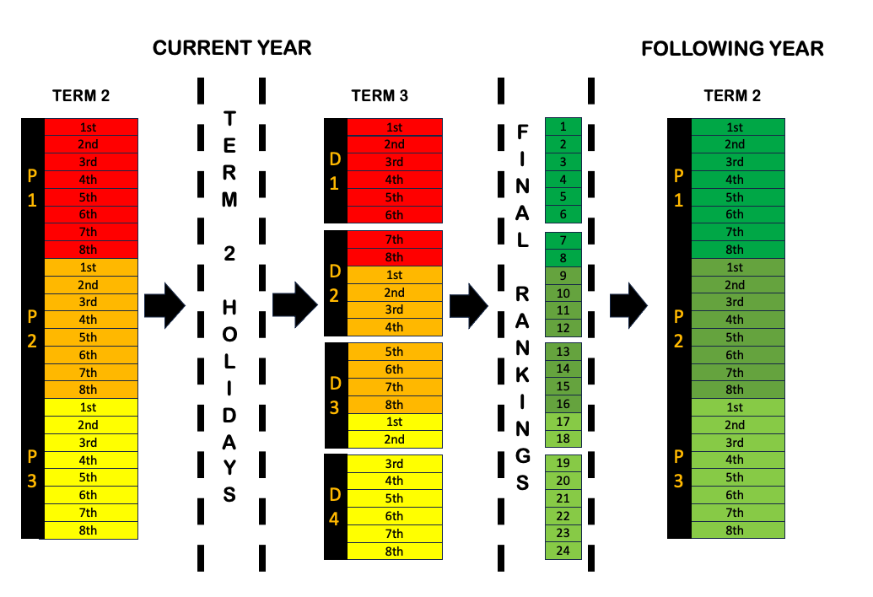
7. RESERVE GRADE COMPETITION STRUCTURE
  - RESERVE GRADE BOYS AND GIRLS FORMAT
    - The competition format for Reserve Boys and Reserve Girls will depend on number of registrations received. The competition format will be communicated to teams prior to the season commencing with the view of creating a meaningful competition. This competition will be 11 a side full field.

    - Combined XI teams, comprising of players from two or more schools, will permitted in Reserve grade.
8. Y9-10 COMPETITION STRUCTURE
8.1 YEAR 9 AND 10 GRADE STRUCTURE
8.1.1 The competition format for Y9-10 will depend on number of registrations received. This competition format will be communicated to teams prior to the season commencing with the view of creating a meaningful competition.
8.2 GRADE SPECIFIC RULES
8.2.1 The Y9-10 competition will be 11-a-side, full field hockey and played over 4 x 15-minute quarters on a Wednesday between 4:00pm and 7:30pm. This Y9/10 grade is designed to be a transition from 7-a-side hockey to 11-a-side hockey, for players to play against their own age group and understand 11-a-side.
8.2.2 The competition will be open to all schools using their own players who are in Y9 or Y10 (or equivalent).
8.2.3 Combined XI teams, comprising of players from two or more schools, will be permitted in the Y9-10 grade. This be must communicated to and approved by WHA.
8.2.4 For 2024, Y9 and Y10 players will be able to play in the P1, P2, P3 and Reserve competition, based on a restricted criteria to manage load. Schools will be expected to manage load for Y9 and Y10 athletes based on Appendix 2.
8.2.5 For 2024 only, Y10s who played 11-a-side in 2023 can continue with their Thursday/Friday teams, but Y9s will be expected to play on Wednesdays primarily.
8.2.6 Dispensation is available, based on development and compassionate grounds, for Y9 and Y10 players to primarily play P1, P2, P3 or Reserve grade instead of Y9/10 grade. See Appendix 3

9. 7-A-SIDE
9.1 7-A-SIDE FORMAT
9.1.1 The 7-a-side competition format will depend on number of registrations received. The competition format will be communicated to teams prior to the season commencing with the view of creating a meaningful competition. This competition will be 6-a-side (plus optional GK) and played on a half field.
9.1.2 Dependent on numbers of registrations, teams may be split into a competitive or social grade.

10. EXTRA TIME PROCEDURES
  - SHOOTOUTS– P1, P2 & P3

10.1.1 Respective team managers or coaches nominate five players to take, and one player to defend, the shootouts from the match card. A player nominated to defend the shootouts can also be nominated to take a shootout. No substitutions/replacements are permitted during the shootout competition, other than as specified below.
    - A player who has been excluded permanently (red card) during the match which leads to the shootout competition, cannot take part in that shootout competition. A player who has been warned (green card) or temporarily suspended (yellow card) may take part in the shootout competition even if the period of their suspension has not been completed at the end of the match.

    - The Match Director or Umpire will specify in advance the goal to be used.

    - The Match Director or Umpire will specify in advance of any possible shootout competition the method of timing taking account of the facilities available and the need to control time accurately.

    - A coin is tossed; the team that wins the toss has the choice to take or defend the first shootout.

    - All players on the team entry form, other than any player who has been excluded permanently (red card) during the match which leads to the shootout competition, are permitted to enter the field of play outside the 23m area used for the shootout but must be at least 10m from the spot where the ball is placed at the start of the shootout.

    - The goalkeeper/defending player of the team taking a shootout may be on the backline outside the circle.

    - A player taking or defending a shootout may enter the 23m area for that purpose.

    - If a player taking a shootout is also defending the shootouts taken by opponents, he/she is allowed reasonable time to take off his/her protective equipment to take his/her shootout and subsequently to put his/her protective equipment on again.
10.1.10 Five players from each team take a shootout alternately against the goalkeeper/defending player of the other team making a total of 10 shootouts.

10.1.11 Taking a shootout:
(a) The goalkeeper/defending player starts on or behind the goal-line between the goal posts.
(b) The ball is placed on the nearest 23m line opposite the centre of the goal.
(c) An attacker stands outside the 23m area near the ball.
(d)The umpire blows the whistle to signal the start of the shootout; the attacker and the goalkeeper/defending player may then move in any direction.
10.1.12 The shootout is completed when:
- 8 seconds has elapsed since the starting signal, or

- A goal is scored, or
- The attacker commits an offence, or the goalkeeper/defending player commits an unintentional offence inside or outside the circle in which case the shootout is re-taken by the same player against the same goalkeeper/defending player, or
- The goalkeeper/defending player commits an intentional offence inside or outside the circle, in which case a penalty stroke is awarded and taken, or
- The ball goes out of play over the backline or side-line; this includes the goalkeeper/defending player intentionally playing the ball over the backline.
- If a penalty stroke is awarded as specified above, it can be taken by anyone on the match sheet who has not been suspended.

10.1.13 A player may be suspended by a yellow or red card but not by a green card during the shootout competition.
10.1.14 If during a shootout competition (including during any penalty stroke which is awarded) a player (either an attacker or a goalkeeper/defending player) is suspended:
- that player takes no further part in that shootout competition and, unless a goalkeeper/defending player, cannot be replaced.

- the replacement for a suspended goalkeeper/defending player can only come from the five players of that team nominated to take part in the shootout competition:

- the replacement goalkeeper/defending player is allowed reasonable time to put on protective equipment similar to that which the goalkeeper/defending player (s)he is replacing was wearing.

- for taking his/her own shootout, this player is allowed reasonable time to take off his/her protective equipment to take his/her shootout and subsequently to put it on again.

    - Any shootout (or penalty stroke) due to be taken by a suspended player counts as no goal; the shootouts taken by this player and scored before being suspended count as a goal.

    - If during a shootout competition, a defending goalkeeper/defending player is incapacitated;

- that goalkeeper/defending player may be replaced by another player from among the players listed on the match card for that particular match, except as excluded in Clause 9.1.2) of this handbook or unless suspended by an umpire during the shootout competition (in this situation, clause 10.1.14 applies).

- The Replacement goalkeeper is allowed reasonable time to put on protective equipment similar to that which the incapacitated goalkeeper/ defending player was wearing.

- If this replacement is also nominated to take a shootout, this player is allowed reasonable time to take off his protective equipment to take his shootout and subsequently to put it on again.

10.1.17 If during a shootout competition, an attacker is incapacitated, that attacker may be replaced by another player from among the players listed on the team match card for that particular match, except as excluded by this handbook or unless suspended by an umpire during the shootout competition.
10.2 SHOOT OUT BETWEEN TWO TEAMS
10.2.1 During a shootout between (only) two teams, if an equal number of goals are scored after each team has taken five shootouts;
a) A second series of five ‘sudden death’ shootouts is taken with the same players, subject to the conditions specified in this handbook.
b) The sequence in which the attackers take the shootouts need not be the same as in the first series.
(c) The team whose player took the first penalty shootout in a series defends the first penalty shootout of the next series.
(d) When one team has scored or been awarded one more goal than the opposing team after each team has taken the same number of shootouts, not necessarily being all five shootouts, that team is the winner (viz., ‘sudden death’).
10.2.2 If an equal number of goals are scored or awarded after a second series of five shootouts, an additional series of shootouts are taken with the same players subject to the same conditions as 10.2.1.
- The sequence in which the attackers take the shootouts need not be the same in any subsequent series.

- The team which starts each shootout series alternates for each series.

- All series remain sudden death as explained in 10.2.1.
10.3 SHOOT OUT BETWEEN THREE OR MORE TEAMS
10.3.1 During a shootout between three (or more) teams.
10.3.2 A round of shootouts is played between each of the teams i.e. Each team plays each other once.
10.3.3 Teams will play in the order determined by the WHA.
10.3.4 Rule 10.1.11 of this handbook will apply to each shootout (viz., five players from each team will take a shootout, making a total of ten shootouts). NB. Rules 10.2.1 and 10.2.2 of this Appendix will not apply (viz., no shootout will go to ‘sudden death’).
10.3.5 A ranking will then be established based upon the results of the round of shootouts only.
10.3.6 In each shootout points will be awarded.
- Three (3) points to the team having scored or been awarded the highest number of goals,

- One (1) point to each team having scored or been awarded an equal number of goals and,

- Zero (0) points to the team having scored or been awarded the lowest number of goals.

    - After each team has played a shootout against every other team, a ranking will be established based upon the total number of points awarded during the round of shootouts.

    - If equality remains between any two or more teams, then the teams having an equal number of points shall be ranked:

(a) According to their respective number of matches.
(b) Should there remain equality between two or more teams then these teams will be ranked according to their respective goal difference (which means ‘goals for’ less ‘goals against’).
(c) Should there remain equality between two or more teams, then these teams will be ranked according to their respective number of ‘goals for’. Applied to goals recorded during the shootout competition.
    - If equality remains between two teams, then procedure in 10.2.1 and 10.2.2 above shall be used to rank the teams.

(a) between three (or more) teams, then procedure 10.2 above shall be repeated until a ranking is determined.
10.4 STROKES – RESERVE AND Y9-10 GRADES (EXCLUDING 7-A-SIDE)
10.4.1 In Reserve grade & Y9-10 finals, no extra time will be played and the game will be decided on penalty strokes as set out below:
10.4.2 Players from the Match card will be chosen and their names given to the umpires (no red carded players).
10.4.3 All team members except the stroke-taker and red carded players should stay behind 23m line.
10.4.4 Umpires will choose the goal to be used and will toss a coin, with the captain who wins the toss choosing which team will go first.
10.4.5 The stroke taker must stand behind and within playing distance of the ball before taking the stroke.
10.4.6 The goalkeeper must stand with both feet on the goal-line and must not leave the goal line or move either foot until the ball has been played.
10.4.7 The stroke will take place once the whistle has been blown.
10.4.8 No delay may occur when taking the stroke.
10.4.9 The stroke-taker must not feint at the ball and must push or scoop it.
10.4.10 The stroke-taker must play the ball once and not approach the ball or goalkeeper after taking the stroke.
10.4.11 If a stroke-taker is suspended, their goal will not count. Any future strokes taken by that player will not count as a goal but any goals before the suspension will be counted.
10.4.12 If a goalkeeper is suspended, they may be replaced by a stroke-taker only. They must wear protective head gear, and any other goal-keepers’ equipment. They may also continue to take strokes.
10.4.13 If a stroke-taker or goalkeeper is incapacitated, they may be replaced by another player on the team sheet, excluding red carded players.
10.4.14 If the score is tied after each team has taken five strokes a second series of sudden death strokes will take place. The same five players are able to take a further stroke in any order if required. The team which went first in the first round will go second in the second round.
10.4.15 The winning team is that which has scored more goals after each team has taken the same number of strokes. i.e., sudden death.
11. COMPETITION FINER DETAILS
11.1 COMPETITION ROUND LADDERS
11.1.1 Teams all start with 0 points.
11.1.2 Team Seedings at the end of the Competition Round will be based on competition points.
11.1.3 If at the end of a round, 2 or more teams have the same number of competition points, they will be ranked by the number of games won.
11.1.4 If there still remains equality between 2 or more teams, then the following order will be used;
(a) Goals for.
(b) Games played between teams in question.
(c) Goal Difference between teams in question.
(d) Goals For between teams in question.
11.1.5 If there remains equality, a penalty stroke competition will determine the Y9-10 and Reserve grade competitions and a shootout will determine the for P1 to P3 seedings (See rules 12.1 and 12.2 respectively).
11.1.6 If there remains equality between more than two teams, the strokes/shoot outs will involve all such teams, with at least five shootouts to be taken. A ranking will then be established based upon the results, 3 points will be awarded to the team with the highest number of goals, 1 point to teams with an equal number of goals and 0 points to teams with the least number of goals.
11.1.7 If there remains equality between more than two teams, those teams having an equal number of points in the penalty stroke/shoot out will be ranked according to rule 12.3 or 12.4.
11.1.8 If there remains equality between more than two teams the same procedure will be repeated until the teams can be ranked.
11.2 COMPETITION POINTS
11.2.1 Win – 3 points.
11.2.2 Draw – 1 point.
11.2.3 Loss – 0 points.
11.2.4 A team winning by default – 3 points with 5 goals awarded.
11.2.5 A team failing to appear for a scheduled game, which has not given notice as per 5.1.1 will have 2 points deducted. Opposing team will be given the win by default.
11.3 FINAL ROUND
11.3.1 No points will be carried over from the competition round over into the final round.

11.4 CARD SYSTEM
11.4.1 Umpires may issue the following cards;
CARD | CONSEQUENCE | JUDICIAL POINTS
Blue Card | Forced Sub (+ 2 Minute Cooldown) | 0 Points
Green Card | 2 Minute Suspension | 1-2 Points
Yellow Card | 5 Minute Suspension | 3-6 Points
Red Card | Sent Off | 12 Points
11.4.2 All players issued with a card must identify themselves to the umpires or WHA. Failure to do so will result in a red card. If a school does not identify the player within 48 hours WHA may suspend the team.
11.4.3 Players who swear on the field of play or show dissent may be suspended. Umpires can impose a maximum of 5 minutes suspension time. Suspensions for swearing will be recorded and repeat offenders may be required to appear before a Judicial Committee.
11.4.4 Further this rule, we are introducing a “Blue Card” for 2024
(a) Blue Cards are designed as a “cooldown” mechanism for individuals. If a player is exercising verbal dissent or frustrations towards an umpire, officials, coaches or other players, the umpires can show the player a “Blue Card”.
(b) Upon receipt of a Blue Card, the player will be required to take a 2-minute suspension, by sitting on the usual “carded player” bench. However, the team can stay at 11 players by substituting the offender as they leave the turf.
(c) Blue Cards may also be shown to coaches, managers, and players not active in the field of play (i.e. on the bench or in the dugout). In this circumstance, the team captain will be required to sit out the 2-minute suspension.
(d) A Blue Card will be awarded for “non-direct” dissent (ie: swearing or murmuring around decisions, not directed towards or directly at the umpire or other players)

(e) Blue cards will not stop or replace the use of green, yellow, or red cards being shown for direct and severe dissent offences

(f) No judicial points will be awarded for a Blue Card.
(g) In the case of an umpire not having a Blue Card, a Blue Card can be signalled by placing one hand over the mouth and using the other hand to signal 2 minutes.
(h) If a team only has 11 players (ie: no substitutes to replace the player), a 2-minute suspension will still stand and the team will play with 10 players. No judicial points will be awarded.

(i) If a team only has one bona fide goalkeeper (ie: no bona fide replacement), the team captain will be required to sit out the 2-minute suspension.

(j) Blue cards can be awarded once per player per game. A direct or severe first offence or a second “Blue Card offence” will result in green, yellow, or red cards appropriately.
11.4.5 If a coach/manager or team official breaches the Code of Conduct, the umpires may suspend a player from the turf. This player will be the captain. Points will be incurred by the offender and WHA will inform the school of the incident.
11.4.6 Points incurred by a player will have a playing season life, after that the points are automatically removed, unless there is a judicial outcome awaiting.
11.4.7 Players who reach 12 points, receive an automatic one game suspension and it is at the discretion of the Judicial Committee if they would like the offender to attend a hearing.
Green & Yellow Cards – 12 Points Accumulated
- A minimum of 1 game suspension.

- Players who incur 12 points will be notified via written notice through the school, of when their suspension will occur.
(c) WHA will confirm the suspension in writing via the school and state any requirements for the player to appear before the Judicial Committee.
(d) The Judicial Committee may require the player to appear before it and may impose an additional suspension if considered necessary. WHA will confirm the penalty in writing to the school.
(e) The player may challenge any card issued, with a $30 fee, which will be forfeited if the challenge is not upheld.
(f) 6 points will remain on the player’s record for the duration of the season.

Red Cards – 12 Points Accumulated
- A minimum 1 game automatic suspension.
(b) The suspension will be automatic.
(c) WHA will confirm the suspension in writing via the school and state any requirements for the player to appear before the Judicial Committee.
(d) The Judicial Committee may require the offender to appear before it and may impose an additional suspension if considered necessary. WHA will confirm the penalty in writing to the school.
(e) 6 points will remain on the player’s record for the duration of the season.

12. JUDICIAL COMMITTEE
12.1 JUDICIAL SYSTEM
12.1.1 The purpose of the Judicial Committee is to deal with any matters arising from breaches of the Code of Conduct.
- The matters may include individuals or umpires. The incidents may be automatic through accumulation of the penalty card points or complaints raised by an individual or school.

- Complaints relating to matters that have been dealt with by an umpire during a game will not usually be considered unless the umpire or a school that was involved raises the complaint.

- The WHA CEO will deal with whole team or school-related behaviour, on or off the field, and if necessary, may involve the WHA Board.

- The Code of Conduct and the full Judicial Rules can be found on the WHA website.

Appendix 1
Rule 4.3.4 – PlayHQ Support
- All players, coaches and team managers must be registered and listed on the gamecard on PlayHQ an hour before the game starts.

- Before the start of the game, the team captains and officials must meet and discuss any discrepancies on the game card.

- Any team with an incomplete or inaccurate game card, unable to provide an explanation for discrepancies, will forfeit the fixture. The game can then be played as a friendly

- After the pre-game meeting with the officials and captains, any team unable to complete their game card before the game starts must provide clear explanations and explain potential discrepancies.

- Using the rules in this handbook as reference, all participants taking the field must be eligible to play. The only reasons that would trigger a forfeiture by one or both teams are:
- Clear intention to field an unregistered or ineligible player
- Clear intention to play a player under a different name
- Clear intention to use a player, coach or manager who is suspended due to judicial or WHA rulings.
(f) Where necessary, umpires and officials may mediate in any discrepancies raised by teams, other than for reasons of forfeiture listed above.
(g) Teams who were forced to forfeit by the officials, are required to email competitions@wellingtonhockey.org.nz to confirm the forfeit, by 12pm on the following Monday

Appendix 2

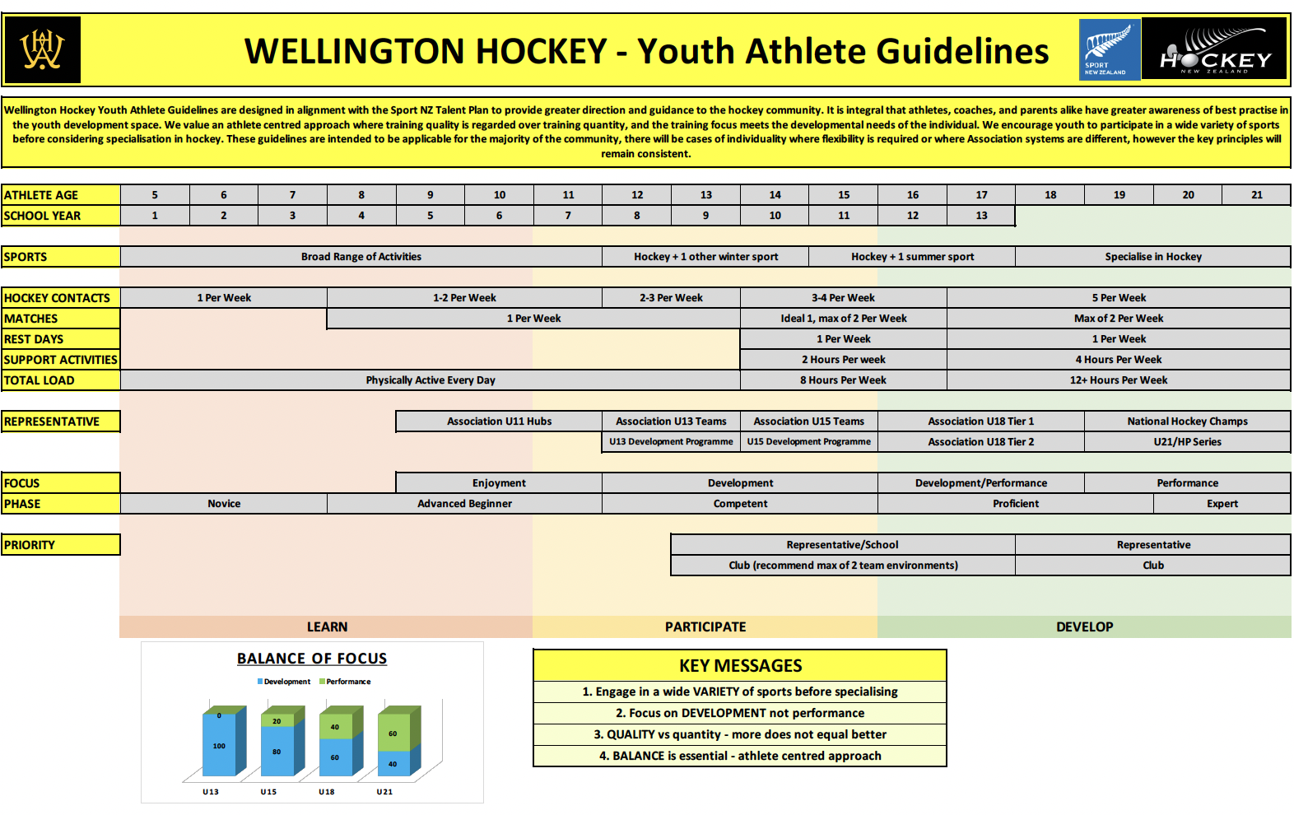

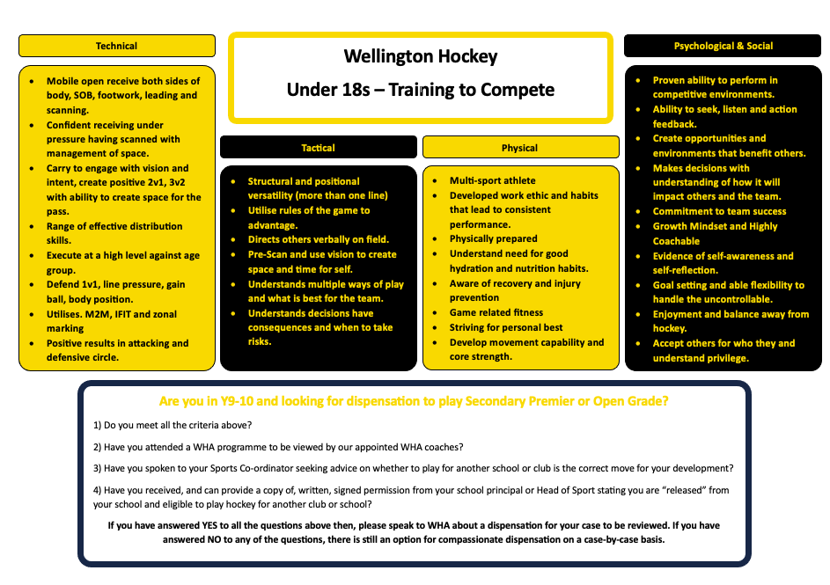
Appendix 3

